PRACTICAL NO. 11

PYTHON AUTOMATION TESTING USING SELENIUM

1. AIM

To perform automation testing of a web application using Python and Selenium WebDriver. The practical includes login verification, product selection, shopping cart verification, checkout form validation, checkout completion, and regression testing.

2. SOFTWARE AND TOOLS REQUIRED

1. Python 3
2. PyCharm IDE
3. Selenium WebDriver
4. Google Chrome Browser
5. Internet Connection
6. SauceDemo Website

3. PROJECT DETAILS

Project Name: Practical_11

Application Under Test: SauceDemo

Module: Login, Products, Shopping Cart and Checkout

Programming Language: Python

Automation Tool: Selenium WebDriver

IDE: PyCharm

Testing Type: Functional Testing and Regression Testing

Test Environment: Windows Operating System with Google Chrome

4. TEST SCENARIO

The objective of this practical is to automate the testing of an online shopping website using Python and Selenium WebDriver.

The automation script opens the SauceDemo website and logs in using valid demo credentials. After successful login, it verifies the products page, adds a product to the shopping cart, checks the cart contents, tests checkout form validation, completes the checkout process, and performs a basic regression login test.

The test scenarios help verify whether the major functions of the web application work as expected.

Test Data:

Username: standard_user

Password: secret_sauce

Product Name: Sauce Labs Backpack

Website: https://www.saucedemo.com/

5. TEST CASE SCENARIOS

TEST CASE 1: LOGIN FUNCTIONALITY

Objective: To verify that a user can log in using valid credentials.

Test Procedure:

1. Open the SauceDemo website.
2. Enter the username "standard_user".
3. Enter the password "secret_sauce".
4. Click the Login button.
5. Verify that the products page opens.

Expected Result:

The user should log in successfully, and the Products page should be displayed.

Actual Result: ______________________________

Status: Pass / Fail

Screenshot 1: Login Page

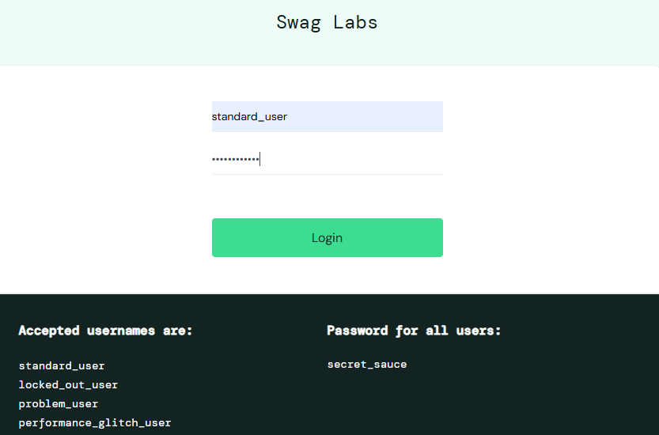

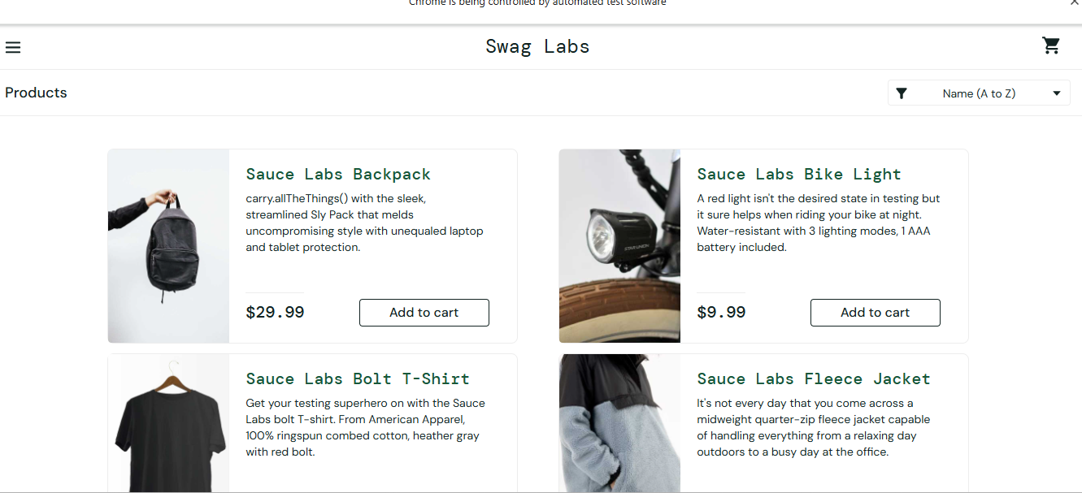

TEST CASE 2: PRODUCTS PAGE VERIFICATION

Objective: To verify that the products page is displayed after successful login.

Test Procedure:

1. Log in to the website.
2. Observe the products page.
3. Verify that the product names and product cards are displayed.

Expected Result:

The products page should display the available products.

Actual Result: ______________________________

Status: Pass / Fail

Screenshot 2: Products Page

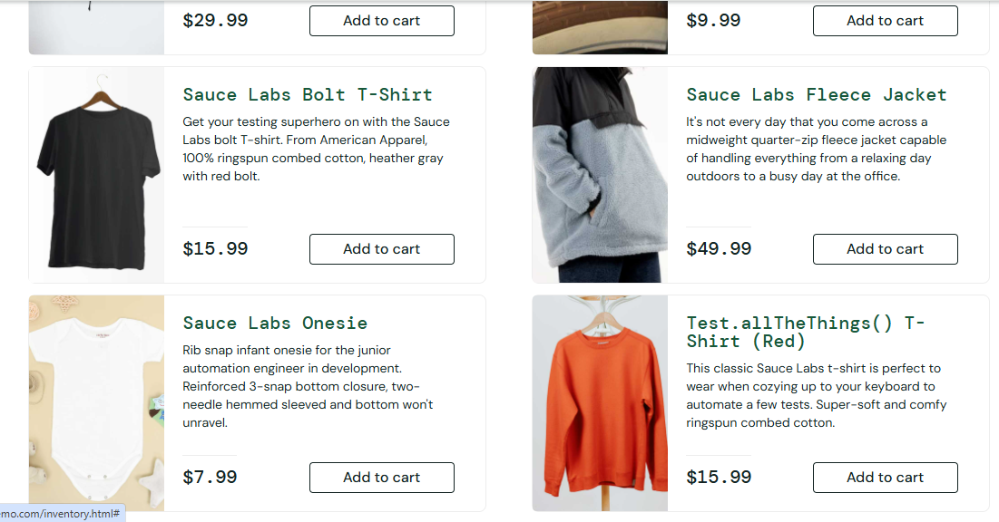

TEST CASE 3: ADD PRODUCT TO CART

Objective: To verify that a product can be added to the shopping cart.

Test Procedure:

1. Open the products page.
2. Find the Sauce Labs Backpack.
3. Click the Add to cart button.
4. Open the shopping cart.

Expected Result:

The selected product should be added to the shopping cart.

Actual Result: ______________________________

Status: Pass / Fail

Screenshot 3: Product Added to Cart
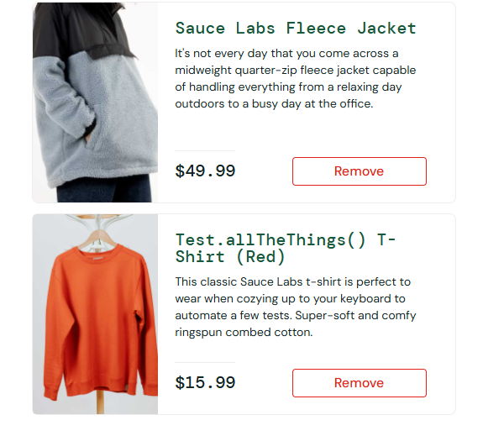

TEST CASE 4: SHOPPING CART VERIFICATION

Objective: To verify that the selected product appears in the shopping cart.

Test Procedure:

1. Click the shopping cart icon.
2. Open the cart page.
3. Check the product name and cart contents.

Expected Result:

The cart page should display the Sauce Labs Backpack.

Actual Result: ______________________________

Status: Pass / Fail

Screenshot 4: Shopping Cart Page

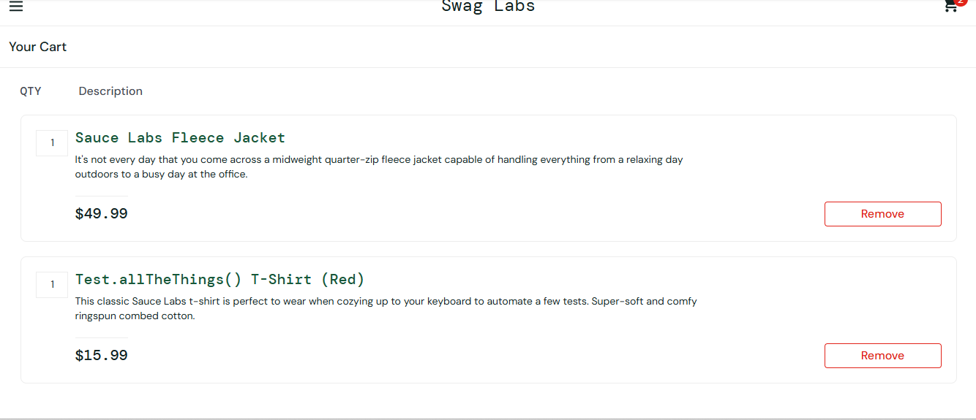
TEST CASE 5: CHECKOUT FORM VALIDATION

Objective: To verify that the checkout form checks for required information.

Test Procedure:

1. Open the shopping cart.
2. Click the Checkout button.
3. Leave the required information blank.
4. Click Continue.
5. Observe the validation message.

Expected Result:

The application should display a validation message when required information is missing.

Actual Result: ______________________________

Status: Pass / Fail

Screenshot 5: Checkout Validation

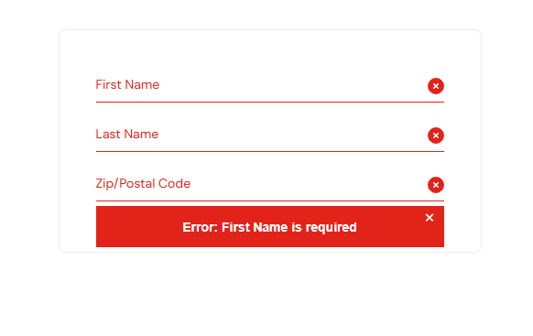
TEST CASE 6: CHECKOUT COMPLETION

Objective: To verify that the checkout process can be completed using valid information.

Test Procedure:

1. Enter the required checkout information.
2. Click Continue.
3. Review the checkout overview.
4. Click Finish.
5. Observe the confirmation page.

Expected Result:

The order confirmation message should be displayed after successful checkout.

Actual Result: ______________________________

Status: Pass / Fail

Screenshot 6: Order Confirmation Page

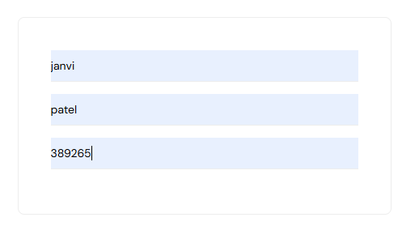

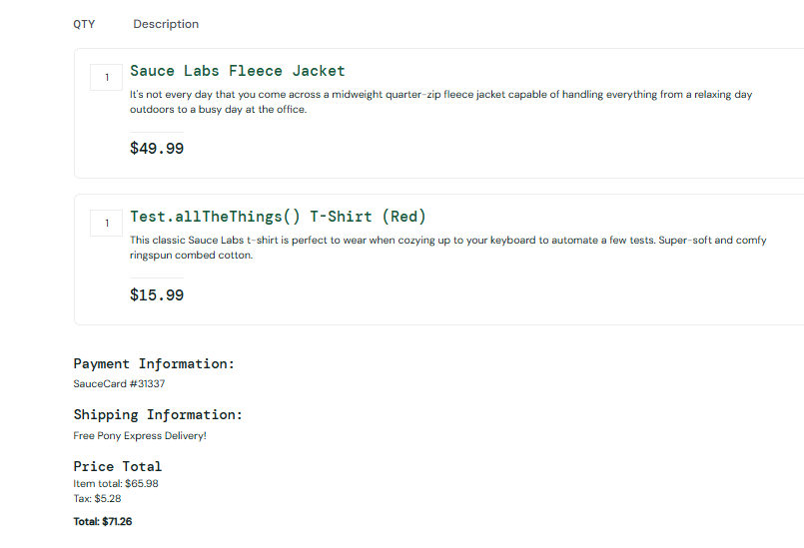

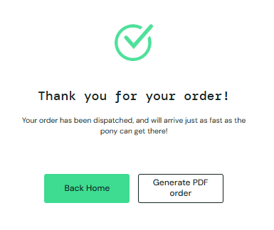

TEST CASE 7: LOGOUT FUNCTIONALITY

Objective: To verify that the user can log out of the application.

Test Procedure:

1. Open the website menu.
2. Click Logout.
3. Observe the page displayed after logout.

Expected Result:

The user should be logged out, and the login page should be displayed.

Actual Result: ______________________________

Status: Pass / Fail

Screenshot 7: Login Page After Logout

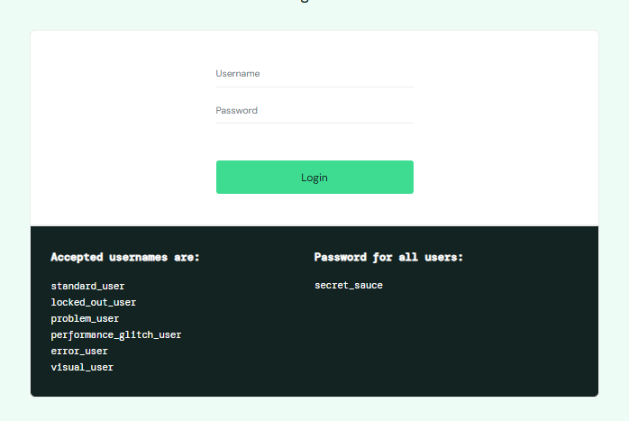
TEST CASE 8: REGRESSION LOGIN TESTING

Objective: To verify that login functionality continues to work during a subsequent test.

Test Procedure:

1. Open the login page.
2. Enter valid demo credentials.
3. Click Login.
4. Verify that the products page opens.

Expected Result:

The application should allow the user to log in successfully again.

Actual Result: ______________________________

Status: Pass / Fail

Screenshot 8: Regression Test Result

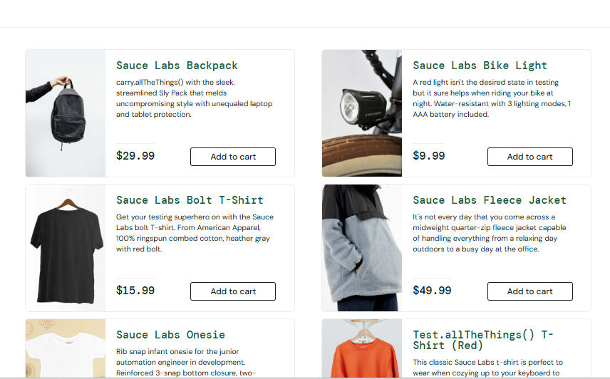
6. PROCEDURE

1. Install Python on the computer.
2. Install and open PyCharm IDE.
3. Create a new Python project named Practical_11.
4. Install the Selenium library in the project environment.
5. Create a Python file for the automation script.
6. Write or paste the Selenium automation code into the file.
7. Run the Python script from PyCharm.
8. Observe the Chrome browser as the automation tests execute.
9. Capture screenshots of the relevant web pages.
10. Record the actual results of the test cases.

7. OUTPUT

The Python Selenium script is used to automate the login, product selection, shopping cart, checkout validation, checkout completion, and regression login test scenarios.

The actual output should be recorded from the PyCharm Run window after executing the automation script.

Output Screenshot:

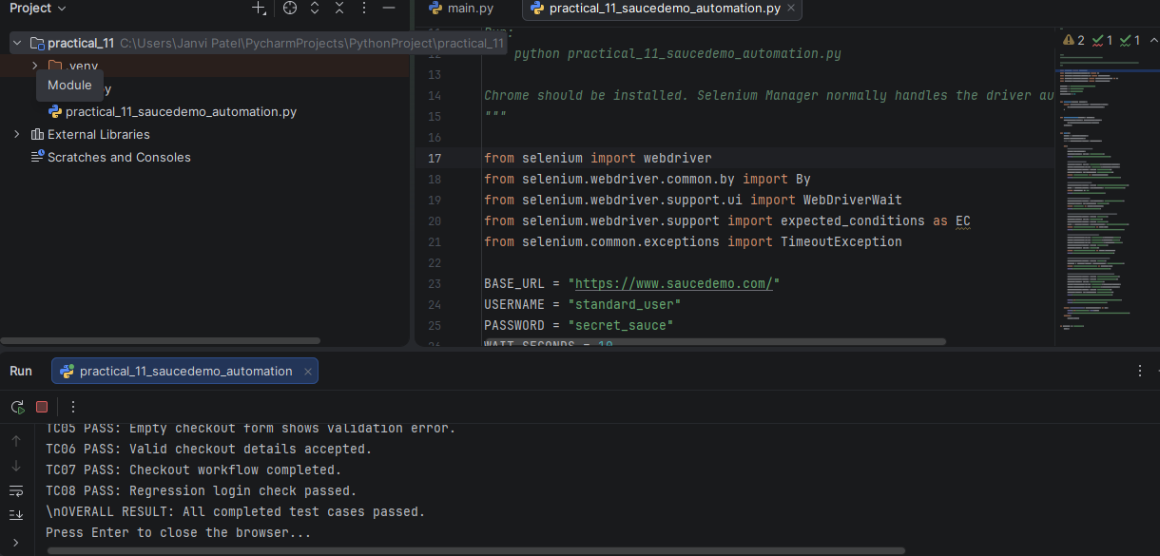
Actual Console Output:

8. OBSERVATION

During the practical, the SauceDemo website is tested using Selenium WebDriver and Python.

The following observations should be recorded after execution:

1. Whether login was successful.
2. Whether the products page was displayed.
3. Whether the selected product was added to the cart.
4. Whether the shopping cart displayed the selected product.
5. Whether checkout validation worked correctly.
6. Whether checkout was completed successfully.
7. Whether logout and regression login worked correctly.

9. RESULT

The web application automation testing practical was performed using Python and Selenium WebDriver.

10. CONCLUSION

This practical demonstrates how Python and Selenium WebDriver can be used to automate web application testing. The practical covers login verification, product display, shopping cart operations, checkout form validation, checkout completion, and basic regression testing.

The test results and screenshots provide evidence of the automation testing performed on the SauceDemo website.

11. PRECAUTIONS

1. Ensure that the internet connection is active before running the script.
2. Use the correct Python interpreter in PyCharm.
3. Install Selenium in the project's Python environment.
4. Do not close the browser while the automation script is running.
5. Capture screenshots from the actual execution.
6. Record the actual test results accurately.
7. Mark a test case as Pass only when the expected result is achieved.

